**Experiment No. 3**

**Aim:** Create application for demonstration of android activity life cycle.

**Program:**

* **Activity.xml:-**

*<?*xml version="1.0" encoding="utf-8"*?>*<LinearLayout xmlns:android="http://schemas.android.com/apk/res/android"  
 xmlns:app="http://schemas.android.com/apk/res-auto"  
 xmlns:tools="http://schemas.android.com/tools"  
 android:layout_width="match_parent"  
 android:layout_height="match_parent"  
 android:orientation="vertical"  
 tools:context=".MainActivity">  
  
 <TextView  
 android:layout_width="wrap_content"  
 android:layout_height="wrap_content"  
 android:id="@+id/txt"  
 android:text="Manish Jadhav"  
 android:layout_marginTop="250dp"  
 android:layout_marginLeft="150dp"  
 />  
  
 <Button  
 android:layout_height="wrap_content"  
 android:layout_width="wrap_content"  
 android:id="@+id/btn"  
 android:text="Submit"  
 android:layout_marginLeft="150dp"  
 />  
  
</LinearLayout>

* **MainActivity.java:-**

package com.example.samp;  
  
import androidx.appcompat.app.AppCompatActivity;  
  
import android.os.Bundle;  
import android.util.Log;  
  
public class MainActivity extends AppCompatActivity {  
 protected void onCreate(Bundle savedInstanceState) {  
 super.onCreate(savedInstanceState);  
 setContentView(R.layout.*activity_main*);  
 Log.*d*("message","onCreate() is called");  
 }  
 protected void onStart(){  
 super.onStart();  
 Log.*d*("message","onStart() is called");  
 }  
 protected void onResume(){  
 super.onResume();  
 Log.*d*("message","onResume() is called");  
 }  
 protected void onPause(){  
 super.onPause();  
 Log.*d*("message","onPause() is called");  
 }  
 protected void onStop(){  
 super.onStop();  
 Log.*d*("message","onStop() is called");  
 }  
 protected void onRestart(){  
 super.onRestart();  
 Log.*d*("message","onRestart() is called");  
 }  
 protected void onDestroy(){  
 super.onDestroy();  
 Log.*d*("message","onDestroy() is called");  
 }  
}

**Output:**

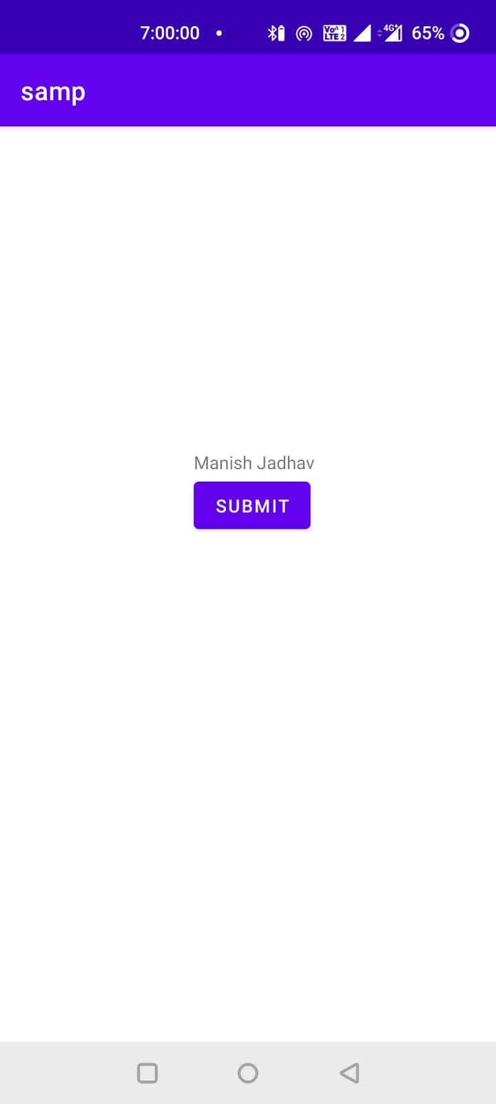

****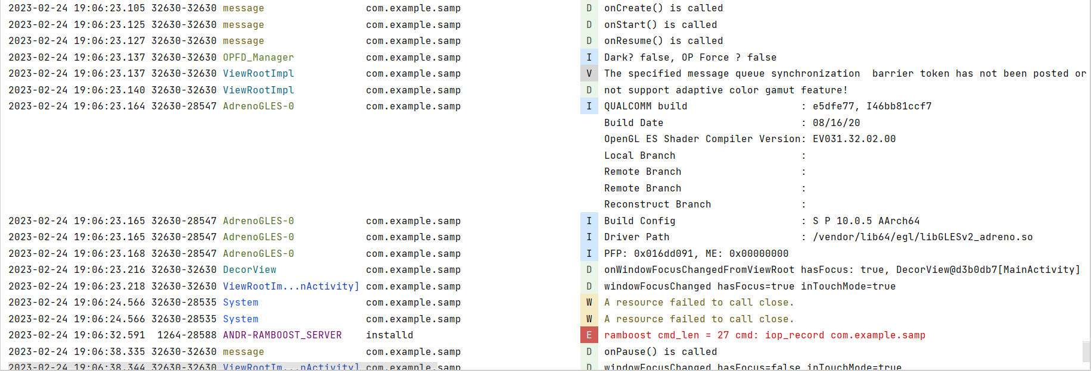



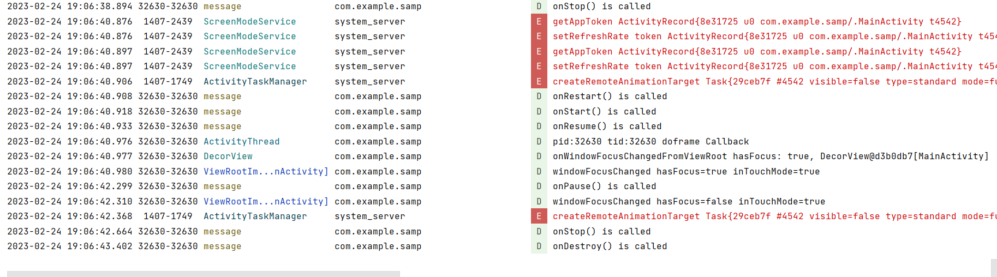



**Conclusion:**

Hence, by completing this experiment I came to know that how to Create application for demonstration of android activity life cycle.

|  |  |  |  |
| --- | --- | --- | --- |
| **Writeup & Oral**  **(4)** | **Practical Performance**  **(4)** | **Attendance**  **(2)** | **Total**  **(10)** |
|  |  |  |  |